**SYNOPSIS**

**Report on**

**CLOUD BASED PAYMENT SYSTEMS VS BLOCKCHAIN BASED PAYMENT SYSTEM**

**by**

Astha Chauhan 2000290140034

Chirag Tyagi 2000290140038

Divyanshu 2000290140044

**Session:2021-2022 (4th Semester)**

Under the supervision of

**Prof. Dr. Arun Kumar Tripathi**

### KIET Group of Institutions, Delhi-NCR, Ghaziabad



### Department Of Computer Applications

**KIET GROUP OF INSTITUTIONS, DELHI-NCR, GHAZIABAD-201206**

(march- 2022)

**ABSTRACT**

Increasing list of records is with blockchain where each record is linked with the help of cryptography. Every block in the chain contains timestamp, transaction details and hash of a previous block, hash is cryptographic hash. This is a secured system, which we plan to replace the current online payment system. A current online payment gateway is prone to hackers where the attacker can tamper into the network, thus creating money loss. And not only this but also the transaction has to go through multiple payment systems which consumes time, also creating a risk of transaction getting failed. So, our system would be using blockchain that allows online transactions which would allow online payments to be sent directly from one party to another without going through a financial institution and in a secured way. This system allows online transactions between two parties based on cryptographic proof without relying and trusting for a third party. To record transactions, we use proof of work algorithm which makes computationally impractical for an attacker to change. Digital signatures provide part of the solution for ensuring the security and integrity of the data that is recorded onto a blockchain.

**TABLE OF CONTENTS**

1. Introduction 4
2. Literature Review 5
3. Research Objective 7
4. Research Methodology 8
5. Research Outcome 9
6. Proposed Time Duration 9

References 10

**INTRODUCTION**

Blockchain is a shared, immutable ledger that facilitates the process of recording transactions and tracking assets in a business network. An *asset* can be tangible (a house, car, cash, land) or intangible (intellectual property, patents, copyrights, branding). Virtually anything of value can be tracked and traded on a blockchain network, reducing risk and cutting costs for all involved.

Business runs on information. The faster it’s received and the more accurate it is, the better. Blockchain is ideal for delivering that information because it provides immediate, shared and completely transparent information stored on an immutable ledger that can be accessed only by permissioned network members. A blockchain network can track orders, payments, accounts, production and much more. And because members share a single view of the truth, you can see all details of a transaction end to end, giving you greater confidence, as well as new efficiencies and opportunities.

**LITERATURE REVIEW**

Nakamoto, Satoshi [1]. In this paper, the complete mechanism of blockchain technology for a electronic cash system that basically allows online payments to be sent directly from one party to another without going through a financial institution is presented. It explains a network system which is distributed i.e. peer to peer network which resulted to be a solution for double spending and the Proof of Work algorithm for carrying out safe and secure transactions.

Judmayer, Aljosha et.al [2] presented an overview of blockchain technology in technical point of view also introduced the concepts of cryptographic currencies and the consensus ledgers. This paper mainly focused on the Bitcoin cryptographic currencies saying that the current scientific community is relatively slowly to this emerging and fastmoving field of blockchain technology reason as not sufficient resources available other than bitcoin. It explained deeply about bitcoin and why it has gained a huge market and interest in today’s technology and also highlights the challenges in the area of digital assets management and presents a discussion of Bitcoin usability, privacy, and security challenges from the user’s perspective, the concept, characteristics, need of Blockchain and how Bitcoin works. It attempts to highlights role of Blockchain in shaping the future of banking, financial institutions.

Zibin Zheng et al. [3] provided an overview of blockchain architecture firstly and compared some typical consensus algorithms used in different blockchains. Also discussed various blockchain based applications that are covering numerous fields like financial services, reputation system, IOT so on. Furthermore, technical challenges of blockchain technology such as scalability of security problems waiting to be overcome and recent advances are briefly listed and possible future trends for blockchain.

In this paper, Luu and other authors [4], investigated the security of running smart contracts based on Ethereum in an open distributed network like those of cryptocurrencies. Author introduced several new security problems in which an adversary can manipulate smart contract execution to gain profit. These bugs suggest subtle gaps in the understanding of the distributed semantics of the underlying platform. As a refinement, author proposed ways to enhance the operational semantics of Ethereum to make contracts less vulnerable. For developers writing contracts for the existing Ethereum system, authors buil a symbolic execution tool called Oyente to find potential security bugs. Among 19, 336 existing Ethereum contracts, Oyente flags 8, 833 of them as vulnerable, including the TheDAO bug which led to a 60 million US dollar loss in June 2016. Author also discussed the severity of other attacks for several case studies which have source code available and confirm the attacks (which target only our accounts) in the main Ethereum network.

Bocek & Stiller [5] discussed about electronic contracts which have gained attention, especially in the context of the blockchain technology. While public blockchains are considered secure, legally binding under certain circumstances, and without any centralized control, they are applicable to a wide range of application domains, such as public registries, registry of deeds, or virtual organizations. As one of the most prominent blockchain examples, the Bitcoin system has reached large public, financial industry‐related, and research interest. Another prominent block‐chain example, Ethereum, which is considered a general approach for smart contracts, has taken off too. Nevertheless, various different set of functions, applications, and stakeholders are involved in this smart contract arena. These are highlighted and put into interrelated technical, economic, and legal perspectives.

**RESEARCH OBJECTIVE**

Our objective with this research project is to replace the current online payment system with mart contract based payment systems. Our system would be using blockchain that allows online transactions which would allow online payments to be sent directly from one party to another without going through a financial institution and in a secured way. This system allows online transactions between two parties based on cryptographic proof without relying and trusting for a third party.

**RESEARCH METHODOLOGY**

1. Referring research papers on Blockchain and smart contracts.
2. The gaps with the ongoing transactions using cloud medium are that they are not fast enough, costly and involves third party which increases the security risks.
3. Our proposed idea is to use smart contracts for transaction purposes which will remove all the current flaws from the existing system.

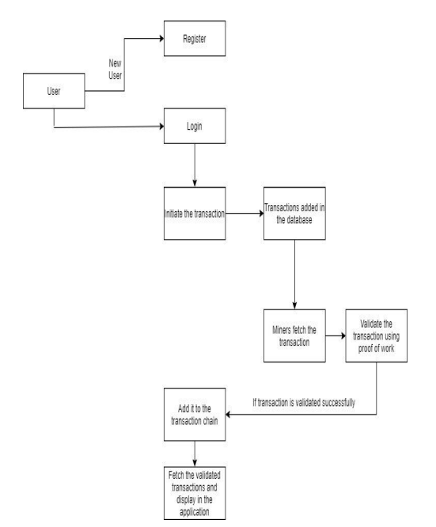

Figure 1: Showing step by step process for transaction using Blockchain

**RESEARCH OUTCOME**

We are focussing on submitting our paper in the following:

1. Scopus Conference (IEEE/Springer)
2. Scopus Journal.

**PROPOSED TIME DURATION**

The estimated time for the completion of this research paper is of 2 months.

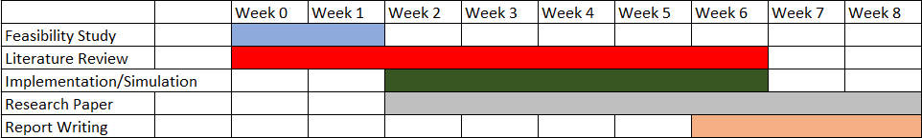

**REFERENCES**

[1] Nakamoto, Satoshi. ”Bitcoin: A peer-to-peer electronic cash system.” (2008). Available Online: https://bitcoin.org/bitcoi

[2] Judmayer, Aljosha, Nicholas Stifter, Katharina Krombholz, and Edgar Weippl. ”Blocks and chains: introduction to bitcoin, cryptocurrencies, and their consensus mechanisms.” Synthesis Lectures on Information Security, Privacy, & Trust 9, no. 1 (2017): 1-123.

[3] Zheng, Zibin, Shaoan Xie, Hongning Dai, Xiangping Chen, and Huaimin Wang. “An overview of blockchain technology: Architecture, consensus, and future trends.” In 2017 IEEE International Congress on Big Data (BigData Congress), pp. 557-564. IEEE, 2017.

[4] Bocek, T., & Stiller, B. (2018). Smart contracts–blockchains in the wings. In *Digital marketplaces unleashed* (pp. 169-184). Springer, Berlin, Heidelberg.

[5] Luu, L., Chu, D. H., Olickel, H., Saxena, P., & Hobor, A. (2016, October). Making smart contracts smarter. In *Proceedings of the 2016 ACM SIGSAC conference on computer and communications security* (pp. 254-269).